**Haramball**

**User Manual**

**By: Hannah Munoz**

**Connor Scully-Allison**

**Kurt Andersen**

**Build Instuctions:**

To run Haramball, ensure that you are in the proper build directory [PA10/build] and compile the code as follows.

cd build

cmake ..

make

To begin playing Haramball, enter the following command:

./Haramball

A new window should appear with the pinball table ready to start. The number of balls left will be displayed on the upper left of the table. The score will be displayed in the terminal once the game has ended and the user has run out of balls.

If you make a top 10 score, you will need to press alt+tab to return to the console, then you will be prompted to input your initials at the end of the game in the terminal.

**Keyboard Inputs**:

**TO AVOID A STICKY SITUATION**(avoiding sticky keys) do not press shift and then any of the arrow keys 5 times consecutively.

*Game Controls:*

Spacebar - press and hold to add force to launch the ball, release to launch ball [Fig. 1]

Right shift – moves right paddle, press and hold to stay in up position. [Fig. 2]

Left shift – moves left paddle, press and hold to stay in up position. [Fig. 3]

Esc – Quits the game.

*Camera Controls:*

Left Arrow – pans the camera to the left.

Right Arrow – pans the camera to the right.

Up Arrow – pans the camera upwards.

Down Arrow – pans the camera downwards.

*'r' –* reset camera position.

*Shader Controls:*

'p' – switch to Phong shading. [Fig. 2 & Fig.3]

'g' – switch to Gourand shading. [Fig. 1]

*Numpad Controls:*

'0' – increases specularity on table [Fig. 4]

'.' - decreases specularity on table

'1' – increases bumper specularity. [Fig. 5]

'2' – decreases bumper specularity

'4' – increases ball specularity. [Fig.6]

'5' – decrease ball specularity

'7' – increases flipper specularity. [Fig. 7]

'8' – decrease flipper specularity

'9' – increase spotlight height [Fig. 8]

'6' – decrease spotlight height.

.

'+' - increase ambient lighting. [Fig. 10]

'-' - decrease ambient lighting.

'*' - increase spotlight ambient lighting. [Fig.11]

‘'/' - decrease spotlight ambient lighting.

**Figures:**

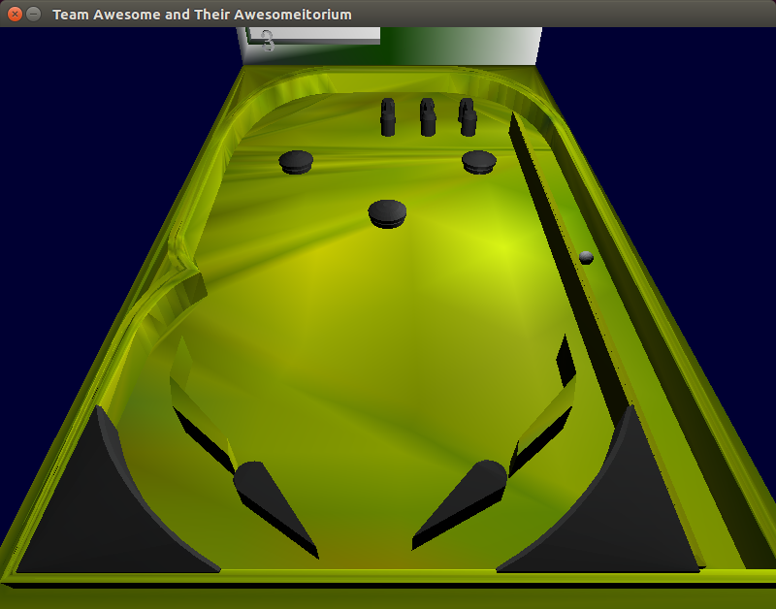

Figure 1: Releasing the space bar applies force to the ball. Also a good example of the Gouraund Shader.

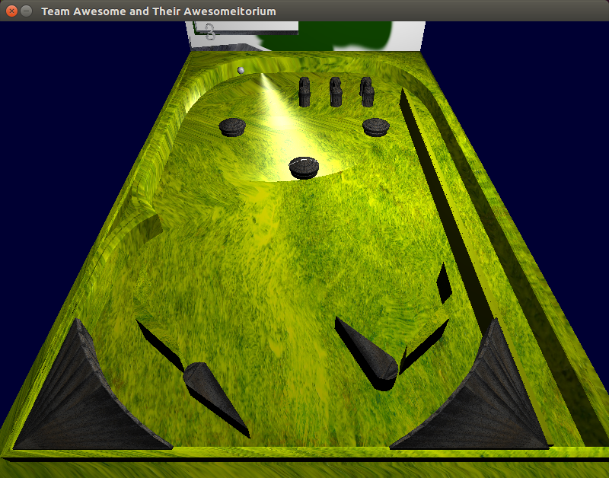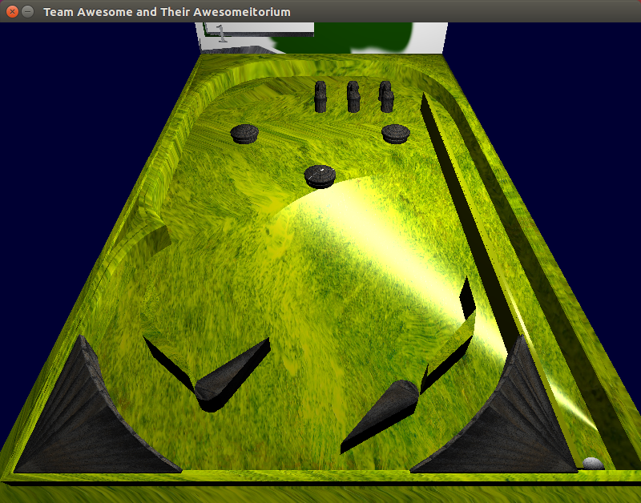

Figure 2 & 3: Hitting the shift keys move the flipper. Also a Good example of the Phong Shader.

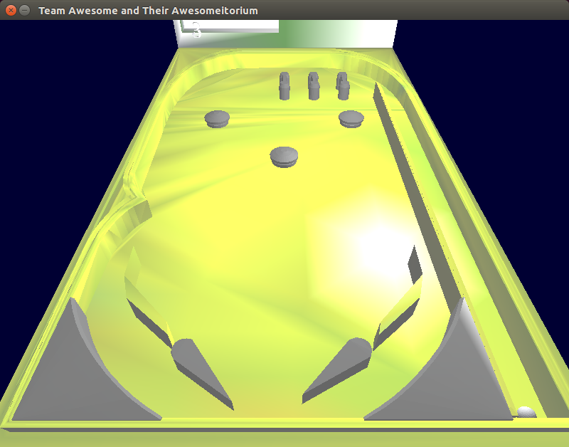

Fig. 4: Increasing the specularity of the table.

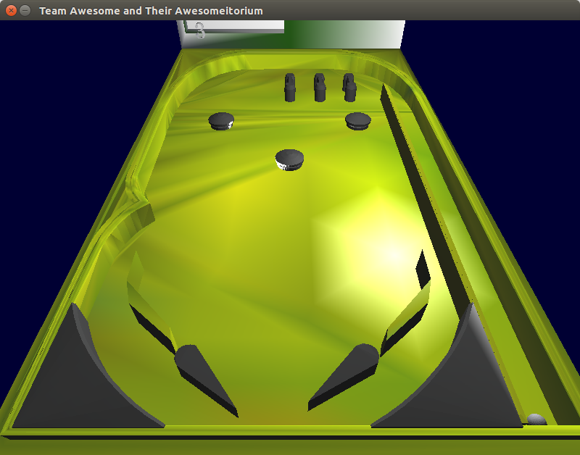

Figure 5: Increasing the specularity of the bumpers

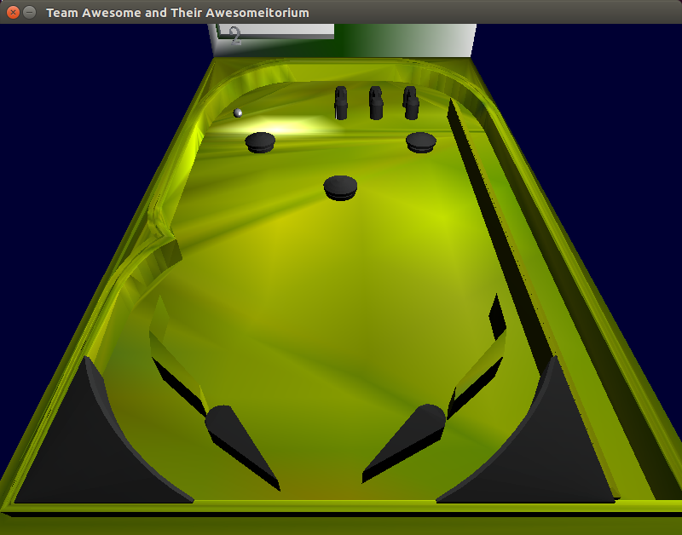

Figure 6: Increasing the specularity of the ball

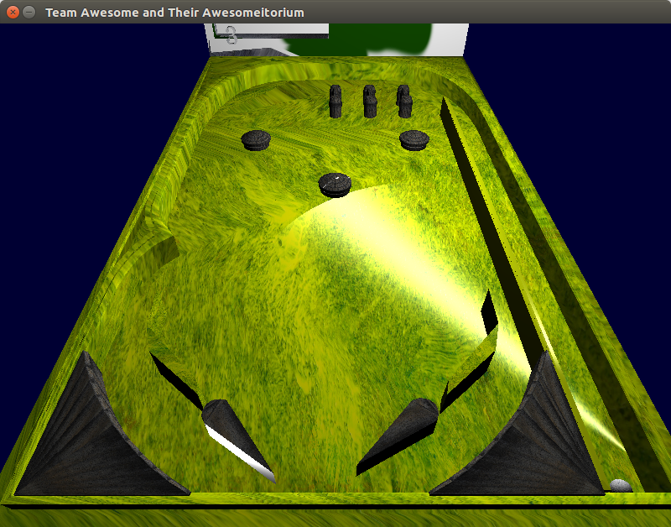

Figure 7: Increasing the specularity of the flippers

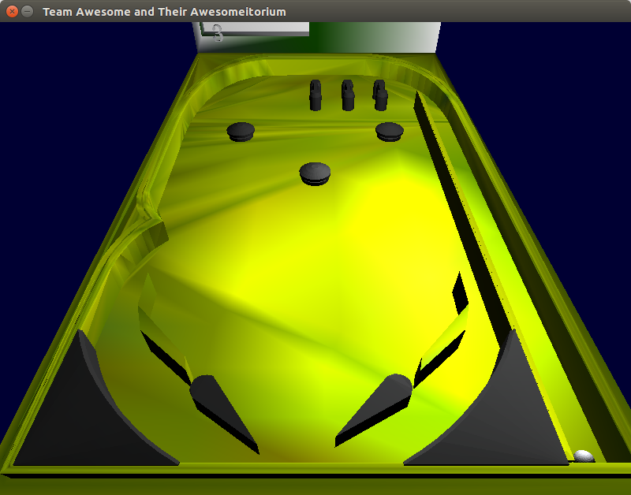

Figure 9: Increasing the spotlight’s height

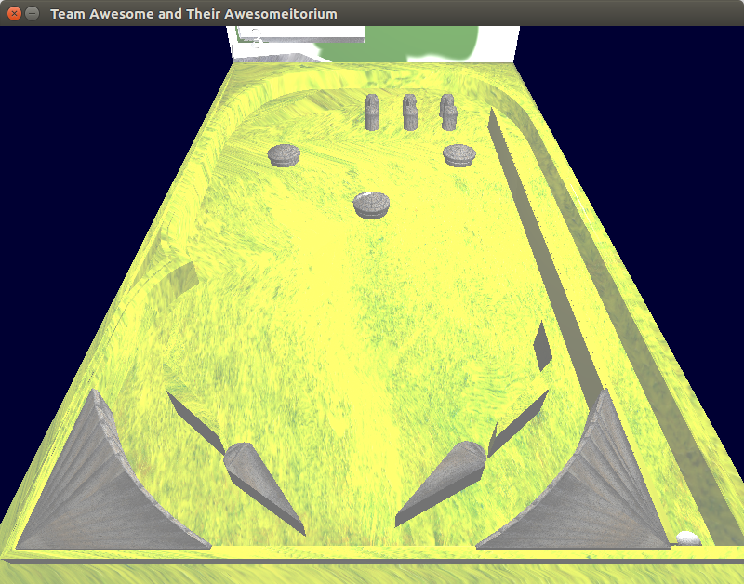

Figure 10: Increase ambient lighting

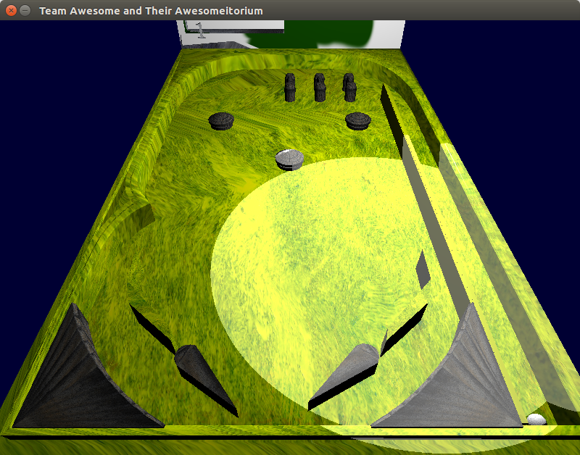

Figure 11: Increase spotlight ambient lighting